**FACTORIAL OF A GIVEN NUMBER**

**EXP NO: 9**

**AIM:** To find the factorial of a given number using 8085 microprocessor.

**ALGORITHM:**

1. Load the data into register B
2. To start multiplication set D to 01H
3. Jump to step 7
4. Decrements B to multiply previous number
5. Jump to step 3 till value of B>0
6. Take memory pointer to next location and store result
7. Load E with contents of B and clear accumulator
8. Repeatedly add contents of D to accumulator E times
9. Store accumulator content to D
10. Go to step 4

**PROGRAM:**

LDA 2001

MOV B,A

MVI C,#01

MVI E,#01

LOOP: MOV D,C

MVI A,00H

LP: ADD E

DCR D

JNZ LP

MOV E,A

INR C

DCR B

JNZ LOOP

MOV A,E

STA 2010

HLT

**INPUT:**

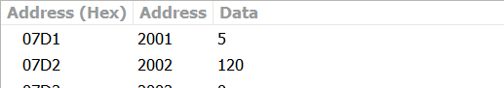

**OUTPUT:**

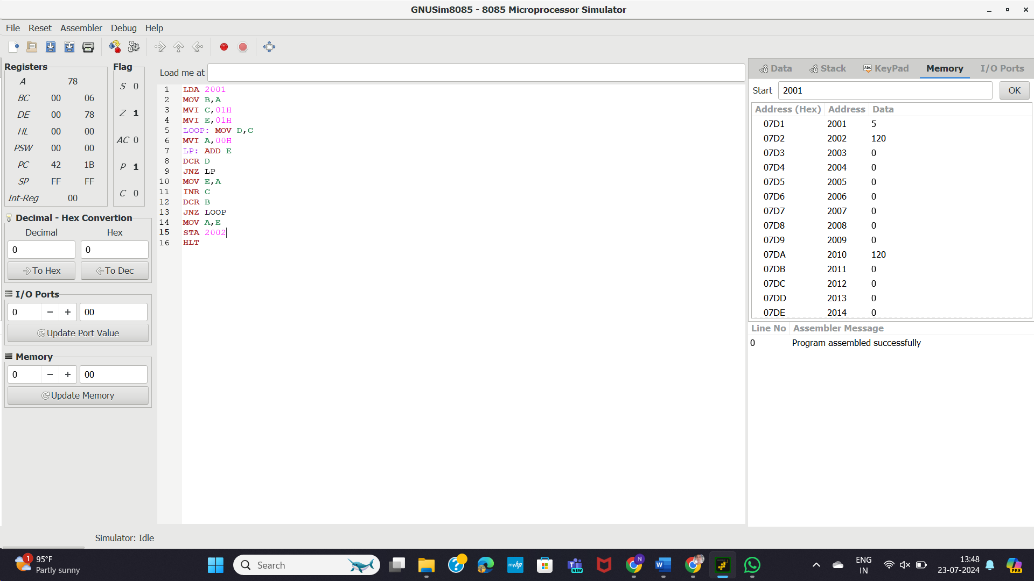

**RESULT:** Thus the program was executed successfully using 8085 processor simulator.